

Be it known that: EMMA B. TIMMINS-SCHIFFMAN

Has satisfied the requirements for a training course in

Biosafety Training

Issued: January 06, 2011 Expiration Date: January 05, 2014

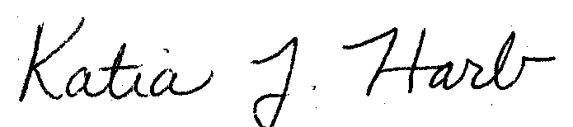
______________________________
Mgr. Research and Biological Safety

This certificate is issued by Environmental Health & Safety

